Visual Studio Code IDE
  - How to install and configure VS Code for programming in C/C++
Preface
Microcontrollers are commonly programmed in the C and C++ programming languages. These programming languages and their compiler technology bring forth native and optimized code for microcontrollers. In the Technology curriculum you will learn how to write programs in C and C++ on your laptop and how to create programs for microcontroller on various embedded boards, e.g. the Arduino, STM32 Nucleo and ESP32. We are using Visual Studio Code (VS Code) as our integrated development environment (IDE) for C/C++ programming. This document is about installing the Visual Studio Code (VS Code) on your laptop together with extensions and additional tools.
By Dr. Gerald H. Hilderink
March 2020

Embedded Systems team
Qin Zhao
Xuemei Pu
Jaap Geurts
Gerald Hilderink

Table of Content
1 Introduction 4
2 Installing VS Code 4
3 Installing add-ons for C/C++ for the PC 5
3.1 Installing VS Code extensions 5
3.1.1 Installing C/C++ extension 5
3.1.2 Installing C/C++ Project Generator extension 6
3.2 Installing GNU C/C++ compiler and debugger 7
3.2.1 Installing the Linux environment 7
3.2.2 Installing the GNU C/C++ compiler toolchain 8
3.2.3 Setting the PATH variable to the C/C++ compiler toolchain 9
4 Installing add-ons for C/C++ for embedded boards 11
4.1 Installing PlatformIO extension for embedded boards 11
5 Programming 13
5.1 Programming in C for the PC 13
5.1.1 Creating a C project 13
5.1.2 Building C programs 14
5.1.3 Running C programs 16
5.1.4 Debugging C programs 17
5.2 Programming in C++ for the PC 17
5.2.1 Creating a C++ project 17
5.2.2 Building C++ programs 17
5.2.3 Running C++ programs 19
5.2.4 Debugging C++ programs 19
5.3 Programming in C for embedded boards 19
5.4 Programming in C++ for embedded boards 20
5.4.1 Creating a C++ project 20
5.4.2 Building C++ programs 22
5.4.3 Running C++ programs 22
5.4.4 Debugging C++ programs 22
6 Printing source code 23
7 Customizing VS Code 23
7.1 Configuring the C/C++ extension 23
7.2 Configuring the build process 23
7.3 Configuring the debug and run process 24
7.4 Configuring the code editor settings 24
8 Troubleshooting 24
8.1 Debugging ‘crtexe.c’ error 24
8.2 C/C++ Project Generator modification 25
9 Useful information 26
10 References 26
11 Notes 26

Introduction
C and C++ are most powerful and popular programming languages for high performance programming. These programming languages are commonly used for, for example, operating systems, device driver, embedded systems, games and real-time applications. A good code editor and toolchain for C and C++ are inevitable. Therefore, you will be using an advanced code editor, namely Visual Studio Code (or VS Code) by Microsoft, for programming in C and C++. You will be using several C/C++ compilers for different target systems. This includes the GNU C/C++ compiler for creating programs on your laptop and C/C++ compilers for creating programs on Atmega, STM32, ESP and possibly other microprocessor boards.
Don’t confuse Visual Studio Code with Visual Studio. These are different IDEs for different targets with a different look-and-feel. Visual Studio is a suite of proprietary tools including a code editor, compiler, debugger and libraries that are specific for the .NET framework. VS Code is an open-source code editor for many programming languages. However, it does not include compilers, tools and libraries. You need to install add-ons, such as extensions (plugins), third-party tools and some configuration to build and upload programs. In the Technology curriculum you will be using VS Code and Visual Studio side by side. For Windows applications you will be using Visual Studio, otherwise you will be using VS Code.
The installation and configuration of VS Code, extensions and additional tools are described in the next sections. This applies to Windows, Linux and macOS users. Linux and macOS users may need to google for additional information on installing tools. In the section ‘Installing add-ons for C/C++ ’ your will learn how to install VS Code for C/C++ programming on your laptop. It also describes how to create, build and run projects on your laptop. In section ‘Installing add-ons for C/C++ for embedded boards’ you will learn how to install the PlatformIO extension in VS Code for creating programs on embedded boards.
IMPORTANT: If you need help, please contact your teacher. Installing and setting up VS Code and tools should not take much time. Failing installation and configuration is no excuse for study delay.

Installing VS Code
It takes a few clicks to install VS Code. Take the following steps to install VS Code on your laptop:
- Go to https://code.visualstudio.com/ and download the VS Code for your operating system.
- Install VS Code on the laptop. In this case install VS Code on your fastest drive.

- Start VS Code and see if it starts.
Figure 1. shows the launch of VS Code. If you don’t see the Explorer view, like in Figure 1, then click the Explorer icon or press Ctrl+Shift+E.
- Close VS Code, because these are some things we need to do first.
After installing VS Code you have a plain code editor. The code editor does not yet support IntelliSense, building, debugging and code browsing for C/C++ source code. You need to install extensions and additional tools for building C/C++ programs specific for your target platform.
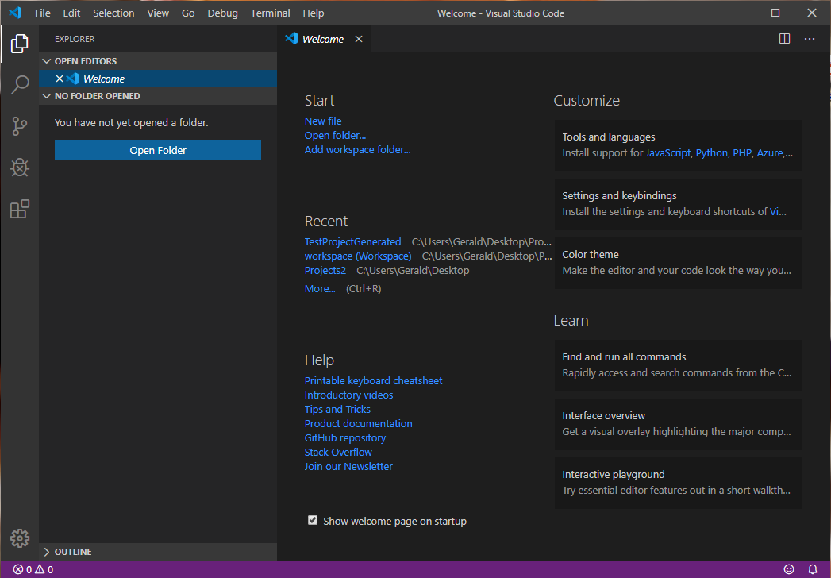
Figure 1. Launching VS Code.

Installing add-ons for C/C++ for the PC
This section is about making VS Code to support for C/C++ for the PC or laptop. You need to install VS Code extensions, compilers, debuggers and additional tools. The steps are described in the following subsections.

Installing VS Code extensions
You need to install some extensions in VS Code to make the code editor support C/C++ programming. The following extensions need to be installed:
- C/C++ extension. Supports IntelliSense and debugging for C/C++ source code.
- C/C++ Project Generator extension. Enables C/C++ projects for building executables for the desktop computers (laptop). This does not include a compiler.

Installing C/C++ extension
Take the following steps to install the C/C++ extension:

- Click on the Extensions view icon on the sidebar in VS Code and a list of extensions will appear. Shortcut is Ctrl+Shift+X.
- Search for “C++” and select the ‘C/C++’ extension by Microsoft. See Figure 2.
Click install.
This C/C++ extension does not include a C/C++ compiler and debugger. These need to be installed separately. This is described in section ‘Installing GNU C/C++ compiler’.
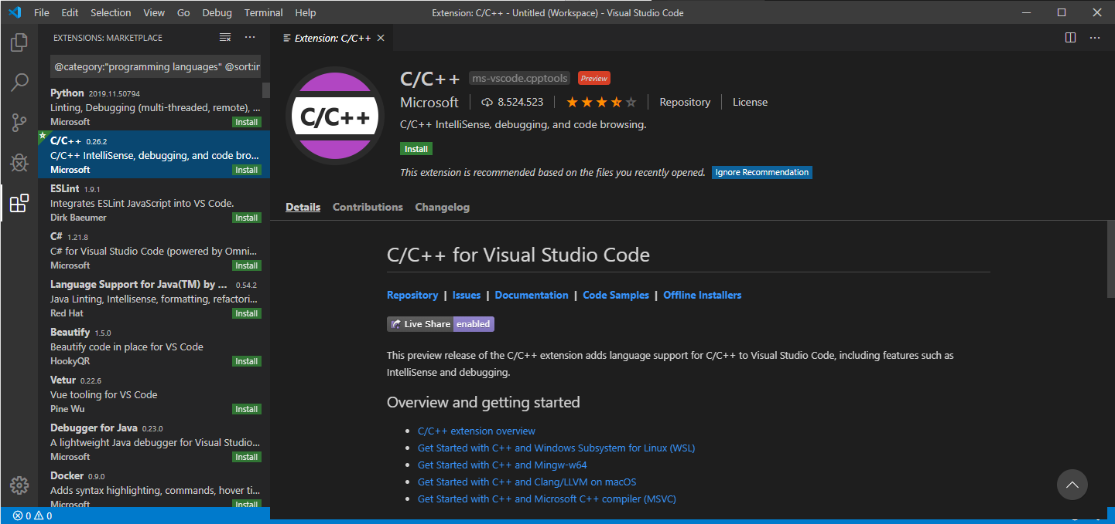
Figure 2. The C/C++ extension by Microsoft.

Installing C/C++ Project Generator extension
VS Code has initially no C/C++ project support. A C/C++ project specifies how the source code must be build and how the files are organized in subfolders. You should install the C/C++ Project Generator extension by danielpinto8zz6. Take the following steps to install the extension:
- Click on the Extensions view icon on the sidebar in VS Code and a list of extensions will appear. Shortcut is Ctrl+Shift+X.
- Search for “C++” and select the ‘C/C++ Project Generator’ extension by danielpinto8zz6. See Figure 3. Click install.
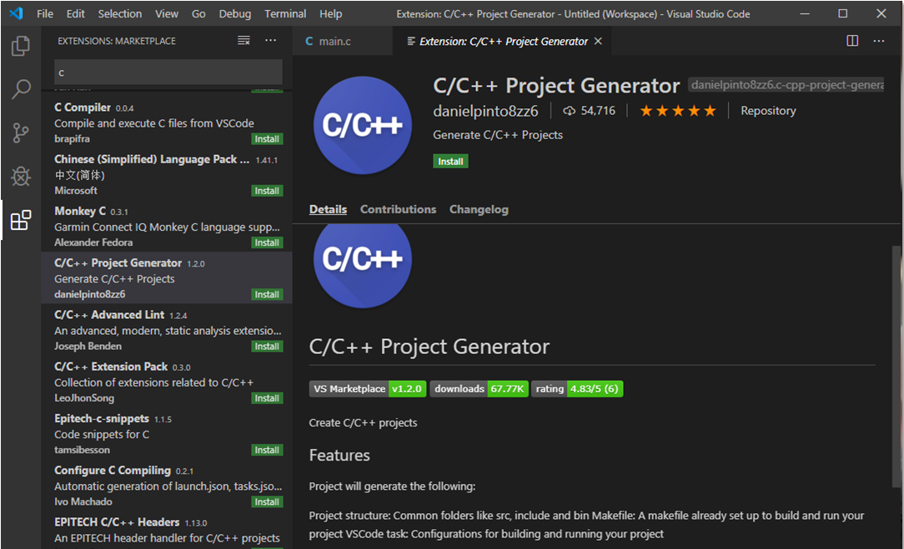
Figure 3. The C/C++ Project Generator by danielpinto8zz6.

Installing GNU C/C++ compiler and debugger
The GNU C/C++ compiler and debugger are free tools licensed under the General Public License (GNU). They come with Linux and they are also available for Windows and macOS. Windows and macOS users need Linux tools that are required for building executables.

Installing the Linux environment

Windows
On Windows you need to install the Linux environment (bash shell, autotools and other Linux tools) for Windows.
We use MSYS2 as our Linux environment for Windows. Do the following steps:
- Go to http://www.msys2.org/ and download the msys2-x86_64-########.exe installer.
- Run the installer and install the software on your laptop.
Here are the screenshots of the installation.
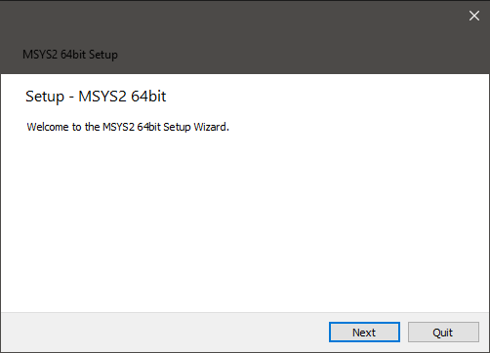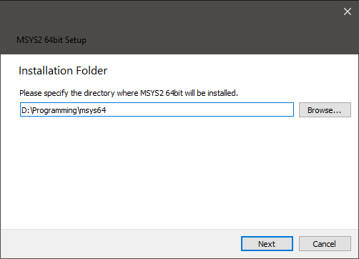
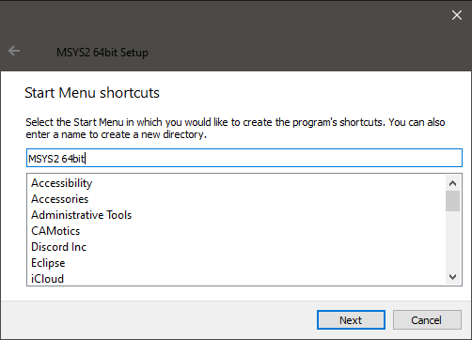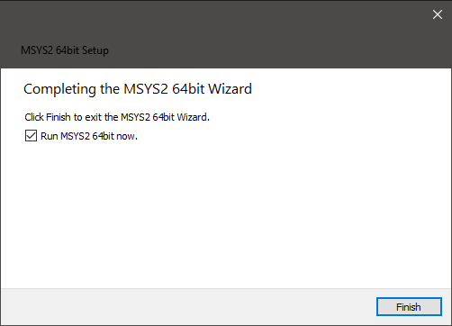
Figure 4. Installation of MSYS2 Linux environment for Windows.
When you click Finish then a Linux environment console will be opened. The console acts as a Linux system without a graphical user interface.
We need to update the package database and core system. In the console you should enter
pacman -Syu
Select Y to proceed installation. After updating the packages, close MSYS2 and run it again from the Start menu. Update the rest with
pacman -Su
Select Y to proceed installation. If successful then the Linux environment is installed, but we are missing the GNU C/C++ toolchain. Please, enter
pwd
and you see your home folder under the installation folder (D:\Programming\msys64\).
In the Start menu ‘MSYS2 64bit’ you can choose MinGW 32-bit, MinGW 64-bit or MSYS. You can choose any of them. You can read more about the differences in (MSYS2 introduction, n.d.).

Linux
Nothing to be done here.

macOS
On the MacOS you need to install the XCode tools to get the Linux environment for macOS. Type the following command in the terminal to install XCode.
xcode-select –install
Since we do not use macOS, please if necessary then google for help.

Installing the GNU C/C++ compiler toolchain

Windows
We will install the GNU C/C++ compiler toolchain using the MSYS2 console. Open the MSYS2 console with Start menu ‘MSYS2 64bit > MSYS2 MSYS’ and enter
pacman -S mingw-w64-x86_64-gcc
Press Y to proceed with the installation. If successful then the compiler toolchain is installed.
We also need the Linux make command for building programs with makefiles. Enter
pacman –S make
Press Y to proceed with the installation.
We also need a debugger in the C/C++ toolchain. Enter
pacman -S mingw-w64-x86_64-gdb
Press Y to proceed with the installation.

Linux
On Linux you can install the C and C++ compilers and debugger with
sudo apt-get install gcc g++ gdb
You need to install the autotools with
sudo apt-get install autotools-dev

macOS
The XCode tools includes Linux tools and a LLVM-GCC compiler. The LLVM-GCC compiler is not similar as the GNU gcc compiler. In order to install the GNU gcc compiler and debugger you should google for information how to install gcc, g++ and gdb for macOS. A source that can be useful is (Compiling GCC 9 on macOS Catalina, n.d.).

Setting the PATH variable to the C/C++ compiler toolchain

Windows
We need to make the Linux tools and the C/C++ compiler reachable for VS Code. Go to the System Environment Variables. You can use search for “environment” in the task bar. See Figure 5.
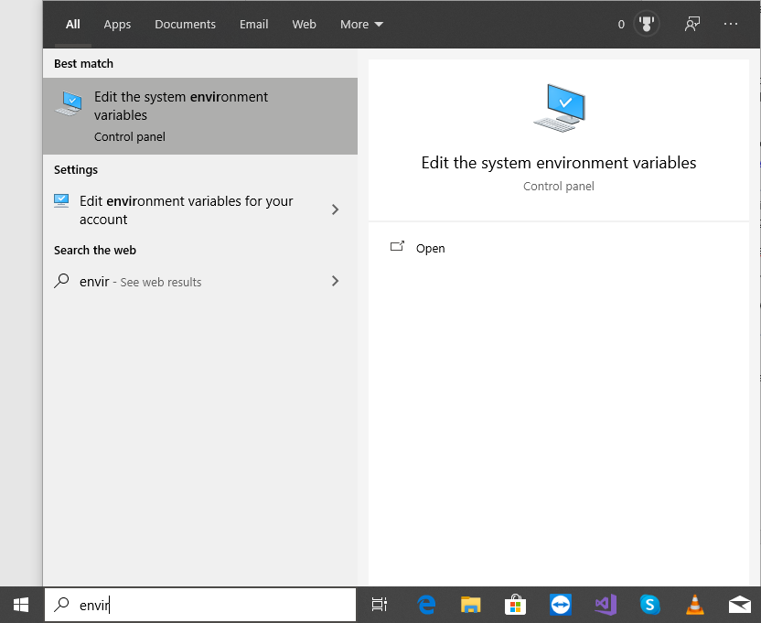
Figure 5. Search for the System environment variables in Windows.
Click ‘Edit the system environment variable’ and the window in Figure 6 will appear. Click on the ‘Environment Variables…’ button which will show the environment variables. Edit the variable Path in section ‘System variables’ and add two paths to the variable. One path contains the Linux tools (e.g. ls.exe) and the other path contains the GNU C/C++compiler executables (e.g. gcc.exe).
For example:
D:\Programming\msys64\usr\bin
D:\Programming\msys64\mingw64\bin
Use the paths of your MSYS2 installation folder. Put these two path are on the top of the list of paths. See Figure 7.
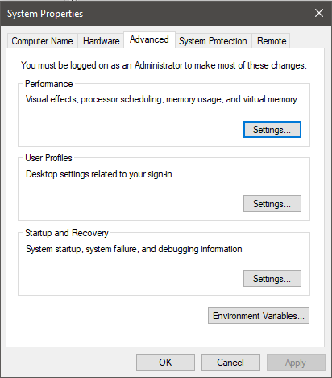
Figure 6. System Properties windows.
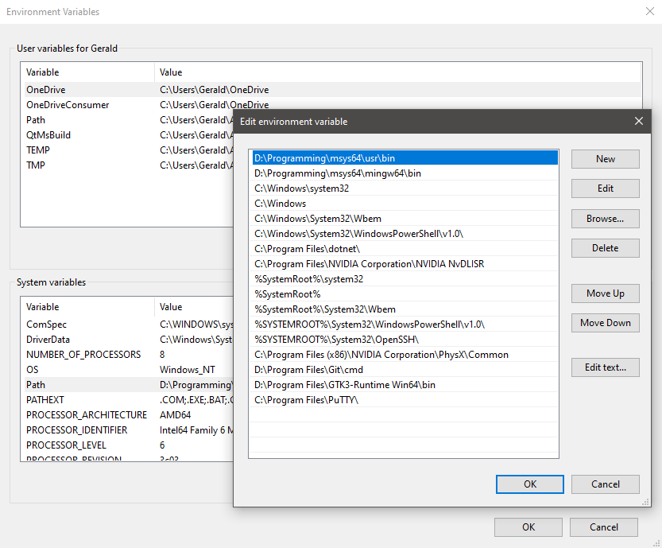
Figure 7. Set the System variables to the Linux tools and GNU C/C++ compiler.
Close the ‘Environment variables’ windows. Now the Linux tools should be reachable by all programs. You can test it by opening the Windows Powershell (use right mouse button on the Start icon in the taskbar of Windows) and enter
gcc
It should show
gcc.exe: fatal error: no input files
compilation terminated.
Note: If the paths are not set in the system variable Path then you will the error “FIND: Parameter format not correct”. The building process will choose the ‘find’ command from Windows instead the one from Linux. The Linux ‘find’ command is required for the ‘make’ process. Again, make sure the previous paths are put on the top of the list of paths, otherwise a wrong ‘find’ command maybe used by the building process.

Linux
Nothing to be done.

macOS
Probably nothing to be done.

Installing add-ons for C/C++ for embedded boards
This section is about preparing VS Code for programming C/C++ for embedded boards with your laptop. You need to install the PlatformIO IDE extension for VS Code. This extension includes a collection of compilers, Software Development Kits (SDKs), libraries and examples for many popular microcontrollers and boards. This extension includes its own project generator.

Installing PlatformIO extension for embedded boards
You should install the PlatformIO IDE extensions by PlatformIO. Take the following steps to install the C/C++ Project Generator extension:
- Click on the Extensions view icon on the sidebar in VS Code and a list of extensions will appear. Shortcut is Ctrl+Shift+X.
- Search for “C++” and select the ‘PlatformIO IDE’ extension by PlatformIO. See Figure 8. Click install.
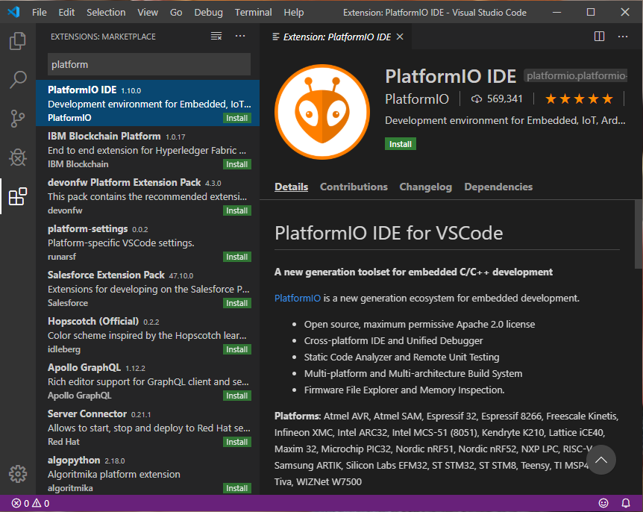
Figure 8. The PlatformIo IDE extension by PlatformIO.
At the bottom bar of VS Code you see that PlatformIO is being installed. See Figure 9. Installation progress of PlatformIO. This may take some time, so be patient.
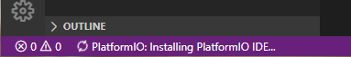
Figure 9. Installation progress of PlatformIO.
After the installation of PlatformIO is completed a message pops up to reload VS Code. See Figure 10.
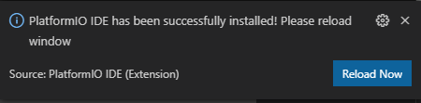
Figure 10. PlatformIO is installed.
The PlatformIO IDE has a main page from which you can create new projects, import Arduino projects, open projects and open examples. See Figure 11.
You can go to the PlatformIO page via the home icon on the bottom of VS Code.
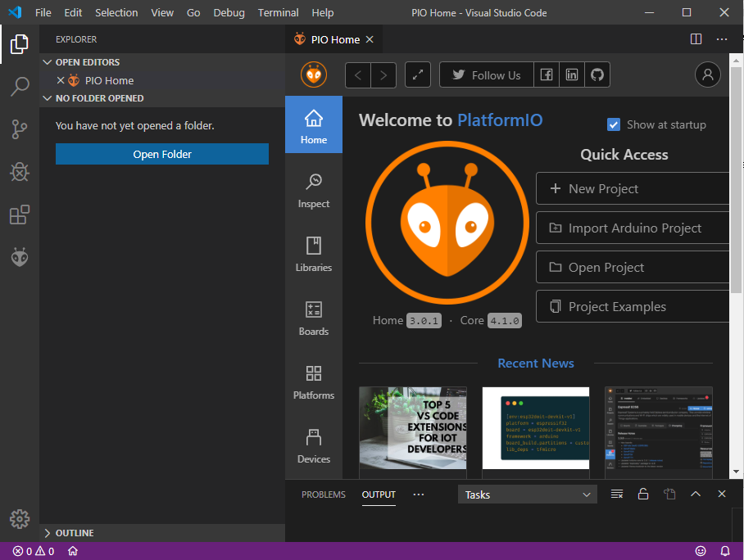
Figure 11. The PlatformIO main page.

Programming
You can choose programming in the C language or in the C++ language. The C++ language supports C, whereas C does not support C++. The C language is very suitable for low-level programming, such as addressing memory, registers and chip functions. C++ is suitable for higher-level programming, such as automated memory management and object-oriented programming.
The first step is to create a C or C++ project for the target platform (PC or embedded board) in VS Code. A project is a folder with a specific structure and settings that is useful to organize source files and to configure the building process for the specific target platform. The C/C++ extension provides commands to create C and C++ projects for the PC and the PlatformIO extension provides commands to create C and C++ projects on various embedded boards. Once you have created a project, you can start programming in C or C++ with VS Code.

Programming in C for the PC

Creating a C project
You have to create a C project for the PC or laptop by executing the ‘Create C project’ command. Press F1 or Ctrl+Shift+P and select ‘Create C project’ in the commands panel. A file explorer appears and you should create a new folder for the project. For example, name it MyCProject. Select the newly created folder and press the ‘Select Folder’ button. Now you see in the Explorer view in VS Code a Workspace MYCPROJECT with a structure of folders and a Makefile file. Your C project has been created. See Figure 12.
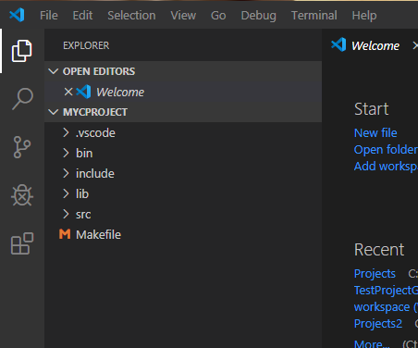
Figure 12. The C project created with command from C/C++ Project Generator extension.

Building C programs
Select in the src folder and select the source code file main.c. This is the main source code with the main(…) function which is the entry point of your executable. On the right side in Figure 13 you see the code. You can build the executable by pressing Ctrl+Shift+B or press F1 and select ‘Tasks: Run Build Task’.
Select the main.c file and press Ctrl+Shift+B to build the executable. You will probably see an error in the terminal output as shown in Figure 13.
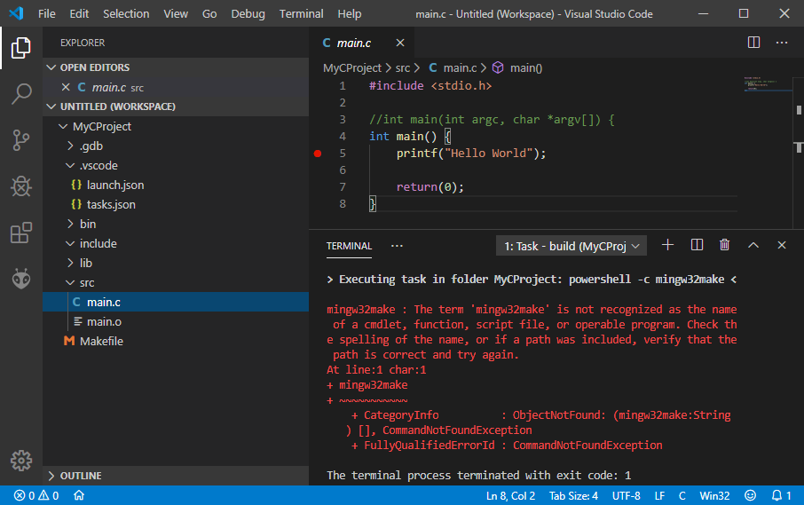
Figure 13. Main source code and build error.
The error is caused by the fact that command mingw32-make does not exist. You can solve this problem by opening the .vscode folder in the Explorer view. Select tasks.json and replace the word “mingw32-make” three times (lines 22, 43, 60) into “make”. See Figure 14. Save the file (Ctrl+S).
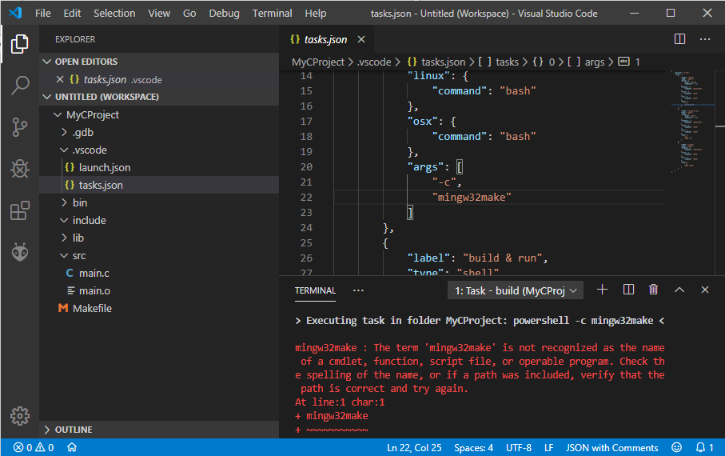
Figure 14. Fix the error in tasks.json.
Build the project again by pressing Ctrl+Shift+B. Now the build process should be successful. See the terminal output in Figure 15. You may have figured out that this build command uses tasks.json to build the project.
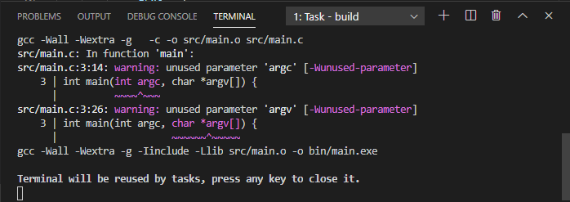
Figure 15. The build process is successful.
In Figure 15, the terminal output shows some warnings with purple colored markers. This is because the variables are unused and these warnings can be ignored. Warnings do not stop the build process whereas errors always stop the build process. We can fix the warnings by changing line 3 in the source code into ‘int main() {‘. Edit the source code as shown in Figure 16.
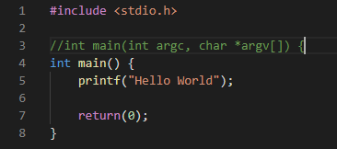
Figure 16. Replacing main(..) into main().
Build the project again with Ctrl+Shift+B and the warnings should be gone. See Figure 17.
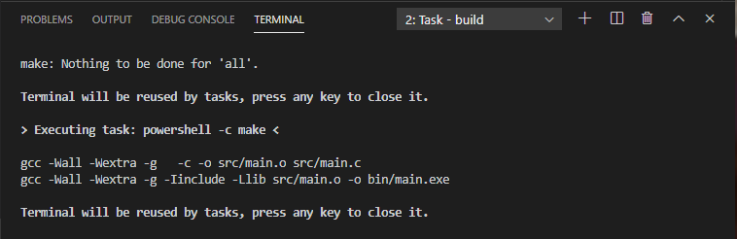
Figure 17. Successful building the project.
Congratulations, you have built your C project. The executable ‘main.exe’ is stored in the bin folder.

Running C programs
You can execute your program in the terminal. Select the TERMINAL tab in the output view. Select option ‘1: powershell’ in the dropdown box. The terminal switches to the powershell mode.
In the powershell, enter the command
./bin/main.exe
and the program will be executed. See Figure 18.
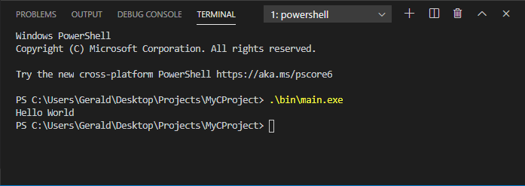
Figure 18. Executing the program.
There is a quick way to switch to the powershell. After building the project you can press the spacebar (or any key) in the terminal output. It will switch immediately to the powershell. In the powershell, you can use the up and down keys to select the commands you have used before.

Debugging C programs
You can debug programs in VS Code by selecting ‘Start Debugging’ in the Debug menu. You need to set the path to the gdb debugger of your toolchain in the launch.json file. Please, add the following line to launch.json.
"miDebuggerPath": "D:/Programming/msys64/mingw64/bin/gdb.exe",
Use the path to your mingw64 folder. See Figure 19.
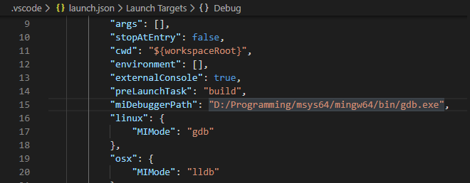
Figure 19. Adding miDebuggerPath to launch.json.

Programming in C++ for the PC

Creating a C++ project
Creating a C++ project is similar to creating a C project. You have to create a C++ project by executing the ‘Create C++ project’ command. Press F1 or Ctrl+Shift+P and select ‘Create C++ project’ in the commands panel. A file explorer appears and you should create a new folder for the project. For example, name it MyCppProject. Select the newly created folder and press the ‘Select Folder’ button. Now you see in the Explorer view in VS Code a Workspace MYCPPPROJECT with a structure of folders and a Makefile file. Your C++ project has been created. See Figure 20.
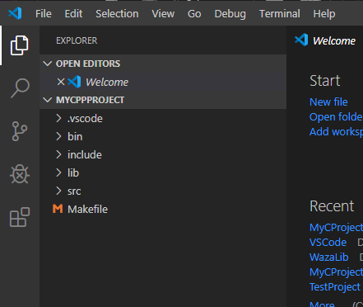
Figure 20. The C++ project created with command from C/C++ Project Generator extension.

Building C++ programs
Building a C++ project is similar to building a C project. Select in the src folder and select the source code file main.cpp. This is the main source code with the main(…) function which is the entry point of your executable. On the right side in Figure 21 you see the code. You can build the executable by pressing F1 or Ctrl+Shift+B and select ‘Tasks: Run Build Task’. Alternatively, select the main.cpp file and press Ctrl+Shift+B to build the executable. You will probably see an error in the terminal output as shown in Figure 21.
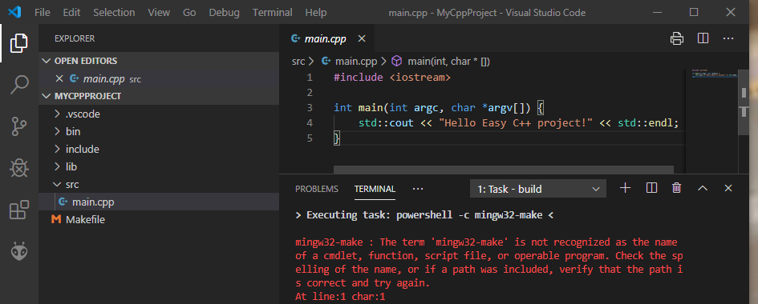
Figure 21. Main source code and build error.
The error is caused by the fact that command mingw32-make does not exist. You can solve this problem by opening the .vscode folder in the Explorer view. Select tasks.json and replace the word “mingw32-make” three times (lines 22, 43, 60) into “make”. See Figure 22. Save the file (Ctrl+S).
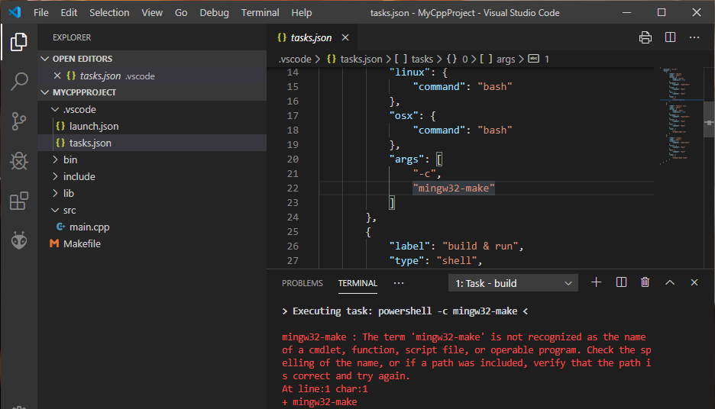
Figure 22. Fix the error in tasks.json.
Build the project again by pressing Ctrl+Shift+B. Now the build process should be successful. See the terminal output in Figure 23. You may have figured out that this build command uses tasks.json to build the project.

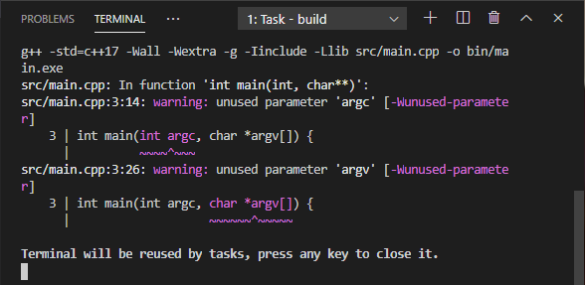
Figure 23. The build process is successful.
In Figure 23, the terminal output shows some warnings with purple colored markers. This is because the variables are unused and these warnings can be ignored. Warnings do not stop the build process whereas errors always stop the build process. We can fix the warnings by changing line 3 in the source code into ‘int main() {‘. Edit the source code as shown in Figure 24.
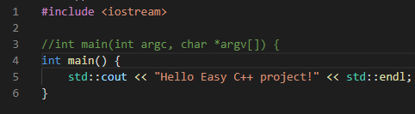
Figure 24. Replacing main(..) into main().
Build the project again with Ctrl+Shift+B and the warnings should be gone. See Figure 25.
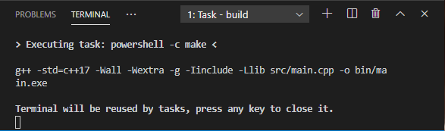
Figure 25. Successful building the project.
Congratulations, you have built your C++ project. The executable ‘main.exe’ is stored in the bin folder.

Running C++ programs
Running a C++ program on the PC is equal to running a C program on the PC. Follow section 5.1.3.

Debugging C++ programs
Debugging a C++ program on the PC is equal to debugging a C program on the PC. Follow section 5.1.4.

Programming in C for embedded boards
The PlatformIO supports C++ by default. However, you can adapt a C++ project for C. Please follow section ‘5.4 Programming in C++ for embedded boards’. After creating a C++ project, you can rename the main source file main.cpp into main.c and you are ready to program in the C language.
Many frameworks are C and C++ based, including the Arduino framework. In main.c you cannot use C++ directly and therefor you cannot use the C++ objects of the framework. Instead, you have to address the C-based Application Programming Interface (API) than is provided by the libraries underneath the framework. For more information, we refer you to the API of the libraries on the internet.

Programming in C++ for embedded boards
Once you have installed PlatformIO successfully, section 4, you can create a new project, import a project, open an exciting project or open examples in the PIO Home page in VS Code.
You can open de PIO Home page by clicking the ‘PlatformIO: Home’ button in the bar at the bottom of VS Code. See Figure 26.
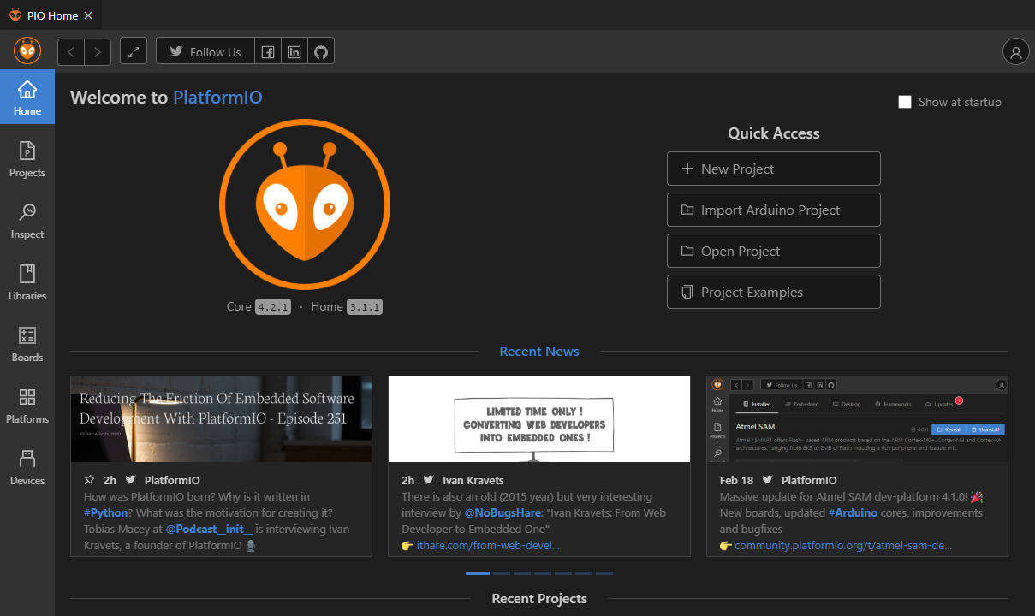
Figure 26. The PIO Home page of PlatformIO.

Creating a C++ project
Go to the PIO Home page by clicking the ‘PlatformIO: Home’ button in the bar at the bottom of VS Code. See Figure 26. Press the ‘+ New Project’ button in the PIO Home page in VS Code and a Project Wizard pops up (Figure 27).
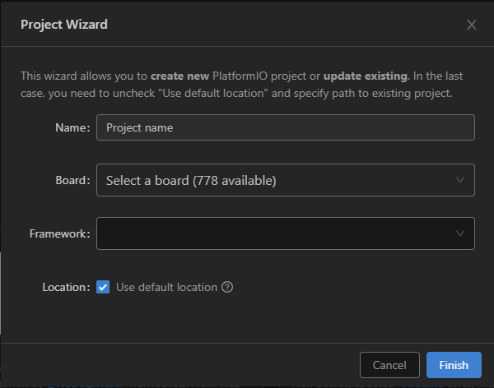
Figure 27. Project Wizard for creating a C++ project.
In the Project Wizard you have to type in your project name, select your board and the framework. PlatformIO support many boards. You can type in the microcontroller number or board type to see if your board is supported. The framework is the Software Development Kit (SDK) you want to use. The type of framework you can select depends on the board you have selected.
For example, for the ‘ST Nucleo L476RG’ board you can select one of the following frameworks:
- Arduino
- Mbed
- STM32Cube
- Zephyr
If you select the Arduino framework then it enables the same SDK as on the Arduino for the ST Nucleo board. In other words, the ST Nucleo board becomes an Arduino compatible board. The other frameworks are more sophisticated and provide low-level performance. We refer you to the websites of these frameworks.
After pressing the ‘Finish’ button it takes some time until the project is created. PlatformIO will create a project structure with default folders (Figure 28).

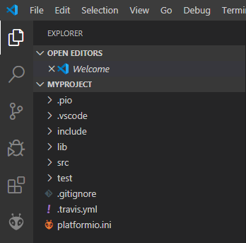
Figure 28. Default C++ project in PlatformIO.
There is no makefile as with C++ projects for the PC or laptop. The PlatformIO extension will generate the makefiles when building the program.
In folder src you will find the main program. See Figure 29.
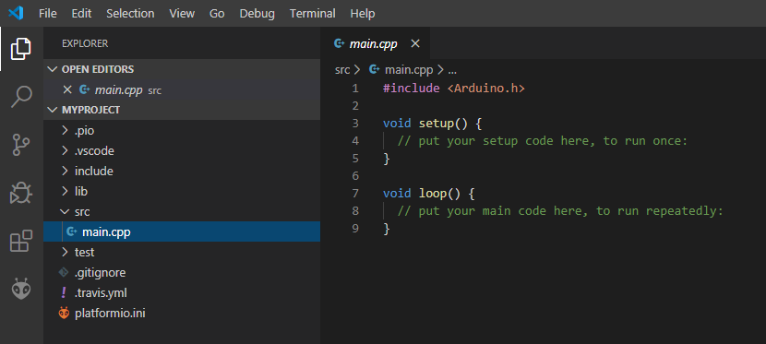
Figure 29. The main source file.
In the bar at the bottom of VS Code you see many buttons. See Figure 30. Some buttons are very similar as to the buttons in the Arduino IDE. Please, hover over the buttons are you will see what their functions are.
Figure 30. Button bar for the Arduino framework.

Building C++ programs
Each framework as its own building process. For the Arduino framework you can select ‘PlatformIO: Build’ button. Alternatively, you can select the main source code and press Crtl+Shift+B and the select ‘PlatformIO: Build’ option.
When you build your program the first time then many other source files are compiled as well. These source files belong to the framework. It may take some time until the build process is completed. Look carefully if the build process was successful and no errors have occurred.

Running C++ programs
For the Arduino framework you can press the ‘PlatformIO: Upload’ button in the button bar (Figure 30). Alternatively, you can press Crtl+Shift+P to execute the Upload command specific for the framework. Normally, after uploading the program it will be executed automatically. If you need to restart the program then you can press the reset button on the board.

Debugging C++ programs
Debugging programs with breakpoints is possible on some boards. Otherwise you should use the serial monitor to print the state of your program as we did with the Arduino Uno. In the menu of VS Code you will find the Debug submenu. This submenu option provides the functions useful for debugging the program.
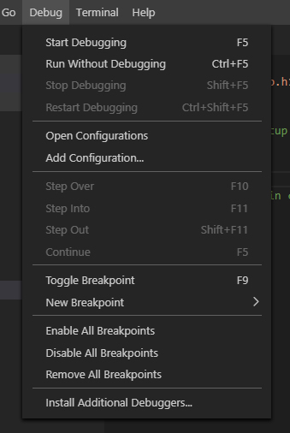
Figure 31. Debug submenu for debugging.

Printing source code
It is not possible to print source code out of the box. You need an extension to enable printing to a printer or to pdf. Go to the Extensions button and search ‘print’. Install the ‘VS Code Printing Free’ by PD Consulting.

Customizing VS Code
VS Code is highly customizable. VS Code is configured by specific text files in JavaScript Object Notation (JSON) format. These setup files have the .json file extension. These setup files are pronounced as jason files. There are plenty of settings you can specify in these files. We discuss a few settings in this document.

Configuring the C/C++ extension
The C/C++ extension can be customized in order to change the behavior of the code editor and the building process. The PlatformIO IDE extension already sets up the C/C++ extension for you.
If necessary, you can customize the behavior of VS Code by opening the C/C++ configuration. Press F1 or Crtl+Shift+P and select ‘C/C++: Configurations (UI)’. On the right side you will see the C/C++ extension settings of the project and on the left side a c_cpp_properties.json file is created in the .vscode folder. All changes you make on the right side will be saved in c_cpp_properties.json file, and vice versa. You can modify/add/remove the C/C++ extension settings in the c_cpp_properties.json file by selecting the file.

Configuring the build process
In section ‘Building C programs’ you have already met the tasks.json file. This setup file is used by VS Code to initiate the build process.

Configuring the debug and run process
In section ‘Debugging C programs’ you have already met the launch.json file. This setup file is used by VS Code to initiate the debugging process.

Configuring the code editor settings
The settings.json file can be used to modify general settings of the code editor. This setup file is not discussed here. See section ‘Troubleshooting’.

Troubleshooting
In this section, specific problems and solutions are described.

Debugging ‘crtexe.c’ error
When you are debugging the main() function in your C program then VS Code may pop up an error message at the last ‘}’. The debugger is missing debug information from a crtexe.c file, because this file is missing. See Figure 32.
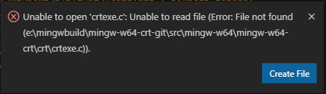
Figure 32. Debug error.
This problem can be solved by pressing the ‘Create file’ button if you have an E: drive. In this case, it creates an empty crtexe.c file to the project. If you don’t have an E: drive then you can create a empty crtexe.c file in the project. Follow the steps:
- Make a folder in the project named .gbg.
- Add the following lines to the “configurations”:[{ … }] section in the launch.json file.
"sourceFileMap": {
"E:/mingwbuild/mingw-w64-crt-git/src/mingw-w64/mingw-w64-crt/crt/crtexe.c":
"${workspaceFolder}/.gdb/crtexe.c"
},
See also Figure 34.
- Create an empty crtexe.c file in the folder .gdb, or perhaps more easy just press the ‘Create File’ button then next time you are going to debug and this create an empty file in the .gdb folder. You can also ask your teacher for the original crtexe.c file. See Figure 33.
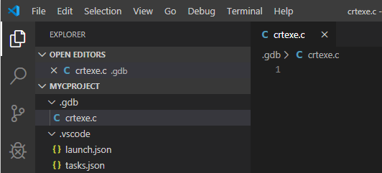
Figure 33. Create a crtexe.c file in .gdb folder.
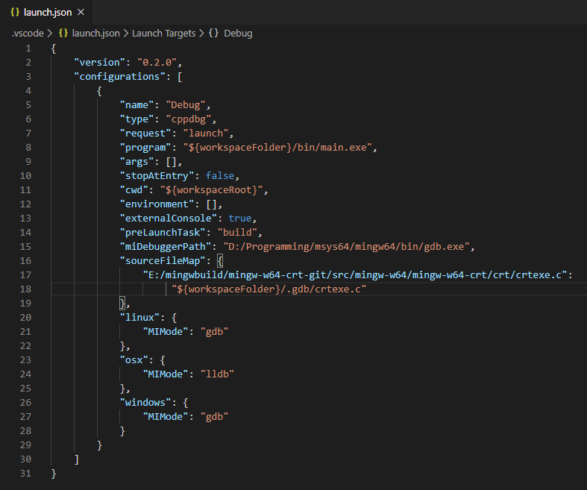
Figure 34. Adapting launch.json to solve crtexe.c problem.

C/C++ Project Generator modification
Every time you create a new C/C++ project and you want to build the project then you get the ‘mingw32-make is not recognized’ error as shown in Figure 14. Each time you can do the steps as described in section ‘Running C programs’. It is handy to make the fix permanent. In this case modify the C/C++ Project Generator extension so that it creates corrected tasks.json files.
Go to the folder
C:\Users\<name>\.vscode\extensions\danielpinto8zz6.c-cpp-project-generator-1.2.0\
where <name> is your personal folder name.
Edit the file out\projects.js with a text editor. Replace the words ‘ming32-make’ with ‘make’. Save and close the file. All newly created C projects should build without ‘mingw32-make is not recognized’ errors.

Useful information
Here you find useful information about the toolchain for C/C++.
Information about VS Code can be found at
https://code.visualstudio.com/
Information about MSYS2 can be found at
https://www.msys2.org/
How to install the mingw64-gcc compiler in MSYS2
https://stackoverflow.com/questions/30069830/how-to-install-mingw-w64-and-msys2

References
Compiling GCC 9 on macOS Catalina. (n.d.). Retrieved from https://solarianprogrammer.com/2019/10/12/compiling-gcc-macos/
MSYS2 introduction. (n.d.). Retrieved from https://github.com/msys2/msys2/wiki/MSYS2-introduction

Notes
- You can use the MSVC compiler from Visual Studio with VS Code. In this case you should read https://code.visualstudio.com/docs/cpp/config-msvc.
- The terms console, terminal and shell are similar things for entering commands via a command prompt.
- Python is a programming language for quickly writing scripts and tools. You should install the Python extension by Microsoft in VS Code. It will use the python tools you have installed on your system. See https://www.python.org/.

