Assignment: Watch

Learning goals 2
Introduction 2
Watch design overview 3
Assignments 5
Part A: implementing bit manipulation 5
Part B (optional): implementing the Watch on an Arduino 5
Appendix: Watch device registers 6
Configuration registers 6
0x20: Configuration register (CONF) 6
Time registers 6
0x21: Time value register MSB (Read/Write) 6
0x22: Time value register LSB (Read/Write) 6
Date registers 7
0x23: Date value register MSB (Read/Write) 7
0x24: Date value register LSB (Read/Write) 7

Learning goals

- Bit manipulation (part A)
- I²C device programming (part B)
- General programming exercise (part C)

Introduction

This assignment will program an I²C Watch device that stores the current time and date. The I²C device has the user registers as given in table 1.

Address | Name | Definition
0x20 | CONFIG | Configuration
0x21 | TIME_BITS_HIGH | Time value (MSB)
0x22 | TIME_BITS_LOW | Time value (LSB)
0x23 | DATE_BITS_HIGH | Date value (MSB)
0x24 | DATE_BITS_LOW | Date value (LSB)
Table 1: User registers of I²C watch device

The device has one register for configuring the watch (CONF) and four other registers for storing the date and time. Both date and time are stored in a 16 bits using two byte registers.

The meaning of the registers in table 1 can be found in the appendix.

Watch design overview

In figure 1 you can find a possible design for the watch. This design assumes that code is running on a device like an PC or Arduino an communicates via I²C with the Watch device.

In order to get the watch running you will have to implement the ‘watch_register’ module. The other modules are already available.

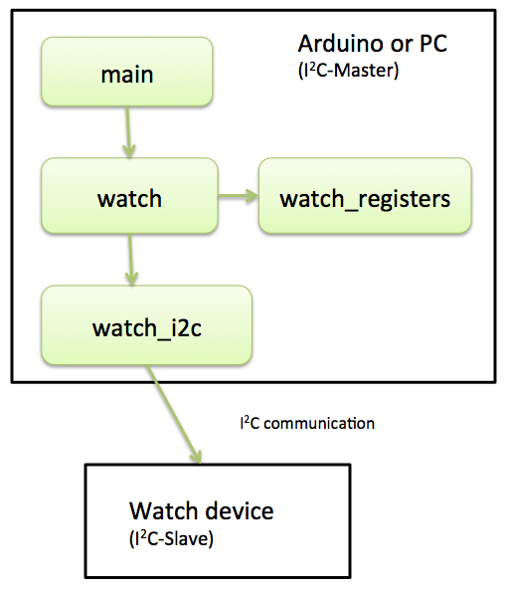
Figure 1: Code modules of the watch design

In table 2 you can find an overview of the modules.

Module | Summary
main | Contains the main method. Show example code on how to use the watch
watch | Control the watch
watch_registers | Manipulates the register bytes of the watch according the register specification (see appendix)
watch_i2c | Sending and retrieving bytes to the Watch device via I²C.
Table 2: Modules of the watch design

In order to decrease development time a simulator for the Watch device is used. The module design using the simulator is show in figure 3.

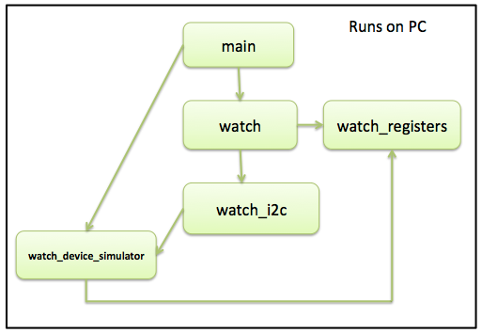
Figure 3: Code modules of the watch design using a simulator

Module | Summary
watch_device_simulator | Contains a simulator for the I²C watch device. The simulator makes use of the module ‘watch_registers’ for manipulating the register values.
Table 3: Modules of the watch design using a watch simulator

For making this assignment you can make use of the ‘Watch’ project code. This project can be compiled and executed on a PC. You can find the build instructions in table 4.

Build instructions: | Description:
make | Builds the executable called ‘build/main. You can run it by executing ./build/main in your terminal.
make test | Builds (build/main_test) and executes the unit tests.
Table 4: Build instructions

Assignments

Part A: implementing register manipulation

Implement the methods as found in ‘shared/watch_registers.h’ for manipulating the watch device registers. Also complete the unit tests in ‘test/watch_registers_test.c’.

Tips:

- Also make sure to read the method documentation in ‘watch_registers.h’ before you start. When for instance setting the hours in the in the TIME_BITS_LOW and TIME_BIT_HIGH you should leave the minute en second bits unchanged. Also note the precondition (@pre) that states that this method may NOT be called with NULL parameters.

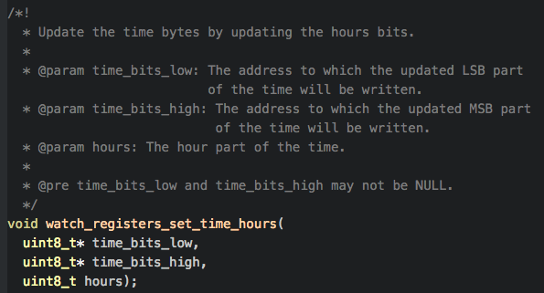

- Make sure to use the register specification as can be found in the Appendix.

Note: for implementing the ‘set’ methods it is not allowed to use the ‘get’ methods. This would decrease the learning effect of this exercise!

Part B (optional): migrating the Watch to Arduino platform (Master + Slave)

Note: this part is likely to more time consuming than part A.

Implement the Watch device on an Arduino. In order to do so you will have to:

- Create code for an Arduino I²C slave that will be the ‘Watch device’. You might reuse parts of the code.

- Create code for an Arduino I²C master. For this you can of course also reuse part of the already available code.

Part C (optional): extending the simulator

The watch simulator currently only provides a bare minimum of functionality. It can for instance be extended to support the configuration settings and date functionality.

Appendix: Watch device registers

Configuration registers

0x20: Configuration register (Read/Write)

7 | 6 | 5 | 4 | 3 | 2 | 1 | 0 | Bit
- | - | - | - | PS | TR[1] | TR[0] | TF | Function
0 | 0 | 0 | 0 | 0 | 0 | 0 | 0 | Default

TF
0: Time format hh:mm
1: Time format hh:mm:ss

TR[1:0]
00: Time refresh disabled
01: Time refresh every 1 second
10: Time refresh every 30 seconds
11: Time refresh every minute

PS[1:0]
0: Time is updated
1: Time updated is paused

Time registers
The time is stored in registers TIMEH and TIMEL:

0x21: Time value register MSB (Read/Write)

7 | 6 | 5 | 4 | 3 | 2 | 1 | 0 | Bit
HR[3] | HR[2] | HR[1] | HR[0] | MIN[5] | MIN[4] | MIN[3] | MIN[2] | Function
0 | 0 | 0 | 0 | 0 | 0 | 0 | 0 | Default

0x22: Time value register LSB (Read/Write)

7 | 6 | 5 | 4 | 3 | 2 | 1 | 0 | Bit
MIN[1] | MIN[0] | SEC[5] | SEC[4] | SEC[3] | SEC[2] | SEC[1] | SEC[0] | Function
0 | 0 | 0 | 0 | 0 | 0 | 0 | 0 | Default

The bits in the above registers store the current time:
SEC[5:0]
The number of seconds (0..59)

MIN[5:0]
The number of minutes (0..59)

HR[3:0]
The number of hours (0..11).
Note: the clock does not support 24-hour time format.

Date registers

The time is stored in registers DATEH and DATEL:

0x23: Date value register MSB (Read/Write)

7 | 6 | 5 | 4 | 3 | 2 | 1 | 0 | Bit
DM[4] | DM[3] | DM[2] | DM[1] | DM[0] | M[3] | M[2] | M[1] | Function
0 | 0 | 0 | 0 | 0 | 0 | 0 | 0 | Default

0x24: Date value register LSB (Read/Write)

7 | 6 | 5 | 4 | 3 | 2 | 1 | 0 | Bit
M[0] | YR [6] | YR [5] | YR [4] | YR [3] | YR [2] | YR [1] | YR[0] | Function
0 | 0 | 0 | 0 | 0 | 0 | 0 | 0 | Default

The bits in the above registers store the current date:
YR[6:0]
The number of years since the year 2000 (0..127)

M[3:0]
The month (1..12)

DM[4:0]
The day of month (1..31)

